Evolution of the Holy Tarot
The Holy Tarot is the key propaganda of any Occult system; at least according to Crowley, and it becomes important to understand its history and evolutionary development. Thelema represents the most recent development within the Western Mystery Tradition; reflected into the Book of Thoth, as well as in our own four-volume set: Thelemic Qabalah, and our book: Thelema & the Greek Qabalah. This stands on the shoulders of the Western Mystery Tradition; also known as the White School of Magick & the Great White Brotherhood.
For the Holy Tarot, its modern history starts with Eliphas Levi, who brought the first mystical innovation to the understanding of these cards by revealing that the letters of the Hebrew Alphabet should be applied to the Major Arcana. This application is found in and said to be from The Book of Hermes, as found Chapter XXII of his book: The Ritual of Transcendental Magic. In this, Levi provides the original order of the cards to be applied to the Hebrew Alphabet in its order, as follows:
Levi’s Atu Numbers | Hebrew Letter | Levi’s Atus
I | Aleph | Le Bateleur  Magician
II | Beth | La Papesse  Female Pope
III | Gimel | Liperatrice  Empress
IV | Daleth | L’Empereur  Emperor
V | Heh | Le Pape  Pope
VI | Vau | Lamovreux  Lover
VII | Zain | Le Chariot  Chariot
VIII | Cheth | La Justice  Justice
IX | Teth | L’Hermite  Hermit
X | Yod | La Rove De Fortune  Wheel of Fortune
XI | Kaph | La Force  Strength
XII | Lamed | Le Pendu  Hanged Man
XIII | Mem | Death
XIV | Nun | Temperance
XV | Samekh | Le Diable  Devil
XVI | Ayin | La Maison Diev  Blasted Tower
XVII | Peh | Le Toile  Star
XVIII | Tzaddi | Le Lune  Moon
XIX | Qoph | Le Soleil  Sun
XX | Resh | Le Judgement  Judgment
0 | Shin | Le Mat  Fool
XXI | Tav | Le Monde  World

Mathers made his own innovation on this, and installed it into official Golden Dawn teachings on the Holy Tarot. First, he thought the placement of the number 0 between XX & XXI was a blind deliberately installed into Levi’s scheme, and that it should precede the number 1. So, the Fool was moved to the top, with Aleph now attributed to it; removing Shin. And the Magician was put down one with Beth now attributed to it. The Hebrew alphabet then continued in its proper order. This literally changes most of the letter attributions to the Major Arcana cards; revealing the blind, as the new letter attributions fit the meaning of the cards more appropriately.
Crowley writes about this in the Book of Thoth:
“One must begin, as a mathematician would, with the idea of Zero, Absolute Zero, which turns out on examination to mean any quantity that one may choose, but not, as the layman may at first suppose, Nothing, in the "absence-of-anything" vulgar sense of the word. (See "Berashith", Paris, 1902).”
Further in the same book, he writes:
“To make it quite clear to initiates that they did not understand the meaning of the card called The Fool, they put him down between Atu cards XX and XXI, for what reason it baffles the human imagination to conceive. They then attributed the card number I, the Juggler, to the letter Aleph. In this simple yet ingenious manner they the attribution of every card, except The Universe, XXI, wrong.
Meanwhile, the true attribution was well guarded in the Sanctuary; it only became public when the secret lection issued to members of the Grade of Practicus of the Hermetic Order of the Golden Dawn was published as a result of the catastrophe attending the English branch of the Order in 1899 and 1900, e.v., and the reconstruction of the whole Order in March and April, 1904, e.v. By putting the card marked 0 in its proper place, where any mathematician would have put it, the attributions fall into a natural order which is confirmed by every investigation.”
The Golden Dawn also attributed astrological and alchemical signs to the Major Arcana. This represents a major development in the understanding of the Holy Tarot and its importance in the Western Mystery Tradition. But also, while refitting the Major Arcana to the order of the Hebrew alphabet, Mathers also switches what are now the order of the VIIIth and XIth atus. This, he claims better represents the Qabalah of the Golden Dawn. In Levi’s original order, VIII is Justice and XI is Fortitude or Strength. Considering the order of the Zodiac, the Golden Dawn scheme works much better, as Justice holds the scales of Libra, and Strength better fits Leo, the Lion. Other changes may be considered to be minor; the Papess is changed to the Empress, and the Pope is changed to the Hierophant. The entire Golden Dawn scheme is as follows:
Levi’s Atu Numbers | Hebrew Letter | The Golden Dawn’s Atus | The Golden Dawn’s Astrological Signs
0 | Aleph | Fool | Air
I | Beth | Magician | Mercury
II | Gimel | High Priestess | Moon
III | Daleth | Empress | Venus
IV | Heh | Emperor | Aries
V | Vau | Hierophant | Taurus
VI | Zain | Lovers | Gemini
VII | Cheth | Chariot | Cancer
VIII | Teth | Fortitude or Strength | Leo
IX | Yod | Hermit | Virgo
X | Kaph | Wheel of Fortune | Jupiter
XI | Lamed | Justice | Libra
XII | Mem | Hanged Man | Water
XIII | Nun | Death | Scorpio
XIV | Samekh | Temperance | Sagittarius
XV | Ayin | Devil | Capricorn
XVI | Peh | Blasted Tower | Mars
XVII | Tzaddi | Star | Aquarius
XVIII | Qoph | Moon | Pisces
XIX | Resh | Sun | Sun
XX | Shin | Judgment | Fire
XXI | Tav | World | Saturn
The Hebrew Qabalah gives us the scheme for the placement of the Hebrew Letters on the lessor paths of the Tree-of-Life, as follows:

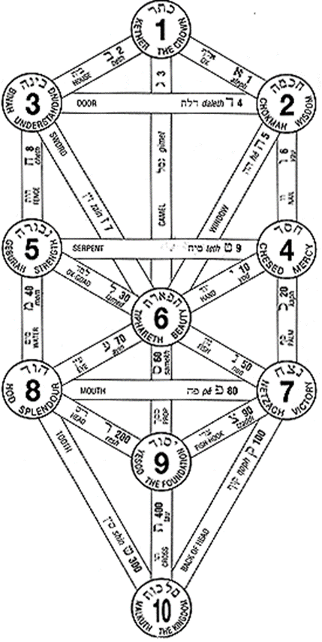
The next major innovation to the Holy Tarot comes from Aleister Crowley. This starts with the Book of the Law, wherein Crowley received a most unusual notion, he claims that during the reception, he asked, “Have I got these attributions right?” with the answer coming immediately in the following verse:
AL:I.57 "Invoke me under my stars! Love is the law, love under will. Nor let the fools mistake love; for there are love and love. There is the dove, and there is the serpent. Choose ye well! He, my prophet, hath chosen, knowing the law of the fortress, and the great mystery of the House of God.
All these old letters of my Book are aright; but j is not the Star. This also is secret: my prophet shall reveal it to the wise."
This is one of the several riddles delivered in this book, which is met by him with the following thought:
It was clear that the attribution of "The Star" to the letter tzaddi was unsatisfactory; and the question arose, how to find another card which would take its place. An incredible amount of work was done on this; in vain. After nearly twenty years the solution appeared.
The Star represents Nuit, the starry heavens. "I am Infinite Space, and the Infinite Stars thereof." (AL. 1.22.) She is represented with two vases, one pouring water, a symbol of Light, upon herself, the other upon the earth. This is a glyph of the Economy of the Universe. It continually pours forth energy and continually reabsorbs it. It is the realisation of Perpetual Motion, which is never true of any part) but necessarily true of the whole. For, if it were not so, there would be something disappearing into nothing, which is mathematically absurd. The principle of Carnot (the Second Law of Thermodynamics) is only true in finite Equations.
The card which must be exchanged for "The Star" is "The Emperor", who bears the number IV, which signifies Power, Authority, Law, and is attributed to the sign Aries.
The Star is Atu number XVII; being counterchanged with the Emperor; Atu IV. They will retain their Atu numbers, but not their positions on the Tree-of-Life; these being counterchanged, along with their letter attributions, which also remain in their original places. Now, astrologically, there is a pattern to be found in this; Aquarius and Aries are on either side of Pisces. And note, we’re still in the astrological Age of Pisces, which exists on the Virgo/Pisces axis on the Wheel of the Zodiac. The other end of the axis, Virgo is surrounded by Libra and Leo, which are the two cards switched by the Golden Dawn. To do this, the Golden Dawn took the cards out of their original order and counterchanged the Strength and Justice Atus; reassigning the Hebrew letter attributions in correspondence. In order to balance this new development, Crowley then returned the two cards to their original position, but retained their new (GD) astrological attributions, while restoring Levi’s original numbers (after accounting for the movement of 0 and the Fool Atu) of the Atus (VIII & XI; respectively), and altering their positions on the Tree-of-Life. From this, Crowley declares:
“…that is to say, the correction in the Book of the Law gives a perfect symmetry in the zodiacal attribution, just as if a loop were formed at one end of the ellipse to correspond exactly with the existing loop at the other end.”
Crowley further justifies this by noting:
“The justice of the exchange is evident when one considers Etymology. It is natural that the Great Mother should be attributed to He', which is her letter in the Tetragrammaton, while the letter Tzaddi is the natural letter of the Emperor in the original phonetic system, as shown in the words Tsar, Czar, Kaiser, Caesar, Senior, Seigueur, Seflor, Signor, Sir.”
Further, the force of the Zodiac is now symbolized as a spiral force, which is quite timely with Einstein’s Relativity Theory that is emerging, to transform both the physical sciences, but also metaphysical philosophy. Crowley applied these zodiacal twists to the Moebius Ribbon, which gives us the following diagram that clearly demonstrates this new development.
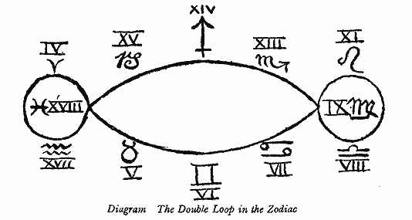
The new diagram of the Tree-of-Life with its new attributions is shown below.
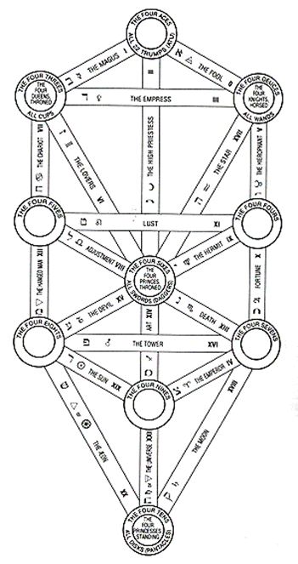
Comparison of the Three Major Developments of the Holy Tarot
I  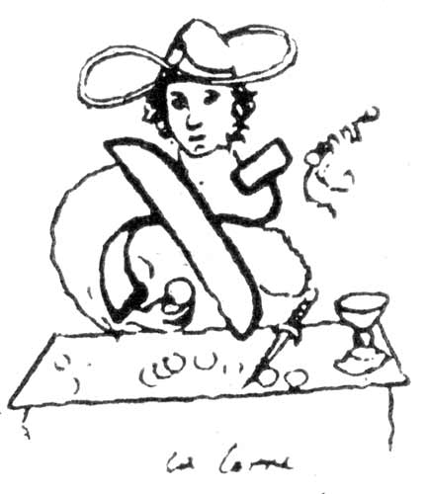  See Note 1  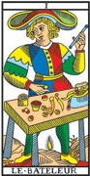 | 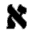 Being, mind, man, or God; the comprehensible object; unity mother of numbers, the first substance.  All these ideas are expressed hieroglyphically by the figure of the JUGGLER. His body and arms constitute the letter ALEPH; round his head there is a nimbus in the form of , emblem of life and the universal spirit; in front of him are swords, cups and pantacles; he uplifts the miraculous rod towards heaven. He has a youthful figure and curly hair, like Apollo or Mercury; the smile of confidence is on his lips and the look of intelligence in his eyes. | 0  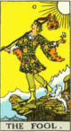  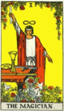 | He is a prince of the other world on his travels through this one-all amidst the morning glory, in the keen air. The sun, which shines behind him, knows whence he came, whither he is going, and how he will return by another path after many days. | 0  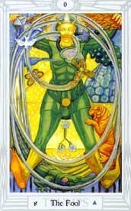  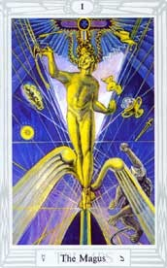 | The really important feature of this card is that its number should be 0. It represents therefore the Negative above the Tree of Life, the source of all things. It is the Qabalistic Zero. It is the equation of the Universe, the initial and final balance of the opposites; Air, in this card, therefore quintessentially means a vacuum.

II  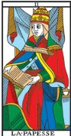 | The House of God and man, the Sanctuary, the law, Gnosis, Kabalah, the Occult Church, the duad, wife, mother.  Hieroglyph of the Tarot: THE FEMALE POPE, a woman crowned with a tiara, wearing the horns of the Moon and Isis, her head enveloped in g mantle, the solar cross on her breast, and holding a book on her knees, which she conceals with her mantle. The protestant author of a pretended history of Pope Joan has met with, and used, for good or bad, in the interests of his thesis, two curious and ancient figures of the Female Pope or Sovereign Priestess of the Tarot. These figures ascribe to her all the attributes of Isis; in one she is carrying and caressing her son Horus; in the other she has long and unbound hair. She is seated between the two Pillars of the duad, has a sun with four rays on her breast, places one hand upon a book and makes the sign of sacerdotal esotericism with the other -- that is to say, she uplifts three fingers only, the two others being folded, to signify mystery. A veil is thrown behind her head, and on each side of her chair the flowers of the lotus bloom upon the sea. I commiserate sincerely the ill-starred scholar who has seen in this antique symbol nothing but a monumental portrait of his pretended Pope Joan. | I  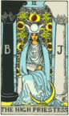 | A youthful figure in the robe of a magician, having the countenance of divine Apollo, with smile of confidence and shining eyes. Above his head is the mysterious sign of the Holy Spirit, the sign of life, like an endless cord, forming the figure 8 in a horizontal position {infinity symbol}. About his waist is a serpent-cincture, the serpent appearing to devour its own tail. This is familiar to most as a conventional symbol of eternity, but here it indicates more especially the eternity of attainment in the spirit. In the Magician's right hand is a wand raised towards heaven, while the left hand is pointing to the earth. This dual sign is known in very high grades of the Instituted Mysteries; it shews the descent of grace, virtue and light, drawn from things above and derived to things below. The suggestion throughout is therefore the possession and communication of the Powers and Gifts of the Spirit. On the table in front of the Magician are the symbols of the four Tarot suits, signifying the elements of natural life, which lie like counters before the adept, and he adapts them as he wills. Beneath are roses and lilies, the flos campi and lilium convallium, changed into garden flowers, to shew the culture of aspiration.. | I  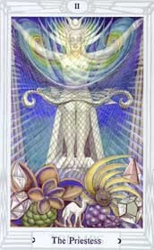 | This card is referred to the letter Beth, which means a house, and is attributed to the planet Mercury. The ideas connected with this symbol are so complex and so multifarious that it seems better to attach to this general description certain documents which bear upon different aspects of this card. The whole will then form an adequate basis for the full interpretation of the card through study, meditation, and use.

III  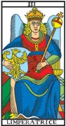 | The word, the triad, plenitude, fecundity, Nature, generation in the three worlds.  Symbol, THE EMPRESS, a woman, winged, crowned, seated and uplifting a sceptre with the orb of the world at end: her sign is an eagle, image of the soul and of life. She is the Venus-Urania of the Greeks and was represented by St John in his Apocalypse as the Woman clothed with the Sun, crowned with twelve stars and having the moon beneath her feet. She is the mystical quintessence of the triad she is spirituality, immortality, the Queen of Heaven. | II  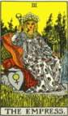 |  | She has the lunar crescent at her feet, a horned diadem on her head, with a globe in the middle place, and a large solar cross on her breast. The scroll in her hands is inscribed with the word Tora, signifying the Greater Law, the Secret Law and the second sense of the Word. It is partly covered by her mantle, to shew that some things are implied and some spoken. She is seated between the white and black pillars--J. and B.--of the mystic Temple, and the veil of the Temple is behind her: it is embroidered with palms and pomegranates. The vestments are flowing and gauzy, and the mantle suggests light--a shimmering radiance. |  | II  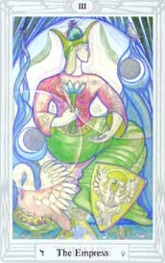 |  | The card refers to the Moon. The Moon is universal, and goes from the highest to the lowest. It is a symbol which will recur frequently in these hieroglyphs. But in the earlier Trumps the concern is with Nature above the Abyss; the High Priestess is the first card which connects the Supernal Triad with the Hexad; and her path makes a direct connection between the Father in his highest aspect, and the Son in his most perfect manifestation. This path is in exact balance in the middle pillar. There is here, therefore, the purest and most exalted conception of the Moon.
IV  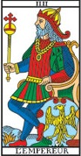 | The porte or government of the easterns, initiation, power, the Tetragram, the quaternary, the cubic stone, or its base.  Hieroglyph, THE EMPEROR, a sovereign whose body represents a right-angled triangle and his legs a cross -- image of the Athanor of the philosophers. |  | III  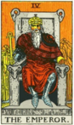 |  | A stately figure, seated, having rich vestments and royal aspect, as of a daughter of heaven and earth. Her diadem is of twelve stars, gathered in a cluster. The symbol of Venus is on the shield which rests near her. A field of corn is ripening in front of her, and beyond there is a fall of water. The sceptre which she bears is surmounted by the globe of this world. She is the inferior Garden of Eden, the Earthly Paradise, all that is symbolized by the visible house of man. |  | III  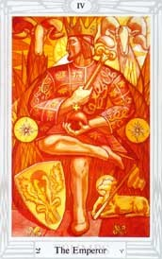 |  | This card is attributed to the letter Daleth, which means a door, and it refers to the planet Venus. This card is, on the face of it, the complement of The Emperor; but her attributions are much more universal.

V  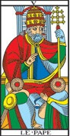 | 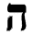 Indication, demonstration, instruction, law, symbolism, philosophy, religion.  Hieroglyph, THE POPE, or grand hierophant. In more modern Tarots this sign is replaced by the image of Jupiter. The grand hierophant, seated between the two Pillars of Hermes and of Solomon, makes the sign of esotericism and leans upon a Cross with three crossbars of triangular form. Two inferior ministers kneel before him. Having above him the capitals of the two Pillars and below him the two heads of the assistants, he is thus the centre of the quinary and represents the divine Pentagram, giving its complete meaning. As a fact, the Pillars are necessity or law, the heads liberty or action. A line may be drawn from each Pillar to each head and two lines from each Pillar to each of the two heads. This gives a square, divided by a cross into four triangles and in the middle of this cross is the grand hierophant, we might almost say like the garden spider in the centre of his web, were such a comparison becoming to the things of truth, glory and light. | IV  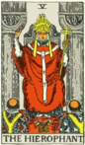 | He has a form of the Crux ansata for his sceptre and a globe in his left hand. He is a crowned monarch--commanding, stately, seated on a throne, the arms of which axe fronted by rams' heads. He is executive and realization, the power of this world, here clothed with the highest of its natural attributes. | IV  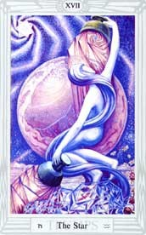  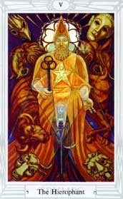 | This card is attributed to the letter He', as has been explained elsewhere. It refers to the Zodiacal sign of Aquarius, the water- bearer. The picture represents Nuith, our Lady of the Stars. For the full meaning of this sentence it is necessary to understand the first chapter of the Book of the Law.  The figure of the goddess is shown in manifestation, that is, not as the surrounding space of heaven, shown in Atu XX, where she is the pure philosophical idea continuous and omniform. In this card she is definitely personified as a human-seeming figure; she is represented as bearing two cups, one golden, held high above her head, from which she pours water upon it. (These cups resemble breasts, as it is written: "the milk of the stars from her paps; yea, the milk of the stars from her paps").

VI  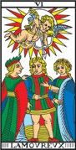 | Sequence, interlacement, lingam, entanglement, union, embrace, strife, antagonism, combination, equilibrium.  Hieroglyph, man between VICE AND VIRTUE. Above him shines the Sun of Truth, and in this Sun is Love, bending his bow and threatening Vice with his shaft. In the order of the ten SEPHIROTH, this symbol corresponds to TIPHERETH -- that is, to idealism and beauty. The number six represents the antagonism of the two triads, that is, absolute negation and absolute affirmation. It is therefore the number of toil and liberty, and for this reason it connects also with moral beauty and glory. |  | V  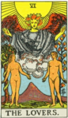 |  | He wears the triple crown and is seated between two pillars, but they are not those of the Temple which is guarded by the High Priestess. In his left hand he holds a sceptre terminating in the triple cross, and with his right hand he gives the well-known ecclesiastical sign which is called that of esotericism, distinguishing between the manifest and concealed part of doctrine. It is noticeable in this connexion that the High Priestess makes no sign. At his feet are the crossed keys, and two priestly ministers in albs kneel before him. |  | V  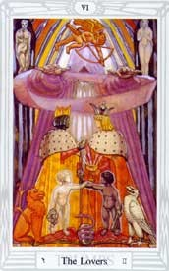 |  |  | The card is referred to Taurus. But the main reference is to the particular arcanum which is the principal business, the essential, of all magical work; the uniting of the microcosm with the macrocosm. In its centre is a pentagram, representing a dancing male child. This symbolizes the law of the new Aeon of the Child Horns, which has supplanted that Aeon of the "Dying God" which governed the world for two thousand years. Before him is the woman girt with a sword; she represents the Scarlet Woman in the hierarchy of the new Aeon.
VII  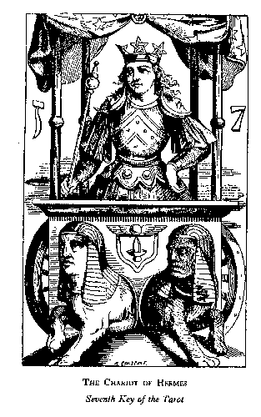  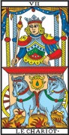 |  | Weapon, sword, cherubic sword of fire, the sacred septenary, triumph, royalty, priesthood.  Hieroglyph, a CUBIC CHARIOT, with four pillars and an azure and starry drapery. In the chariot, between the four pillars, a victor crowned with a circle adorned with three radiant golden pentagrams. Upon his breast are three superposed squares, on his shoulders the URIM and THUMMIM of the sovereign sacrificer, represented by the two crescents of the moon in GEDULAH and GEBURAH; in his hand is a sceptre surmounted by a globe, square and triangle: his attitude is proud and tranquil. A double sphinx or two sphinxes joined at the haunches are harnessed to the chariot; they are pulling in opposite directions, but are looking the same way. They are respectively black and white. On the square which forms the fore part of the chariot is the Indian lingam surmounted by the flying sphere of the Egyptians. This hieroglyph, which we reproduce exactly, is perhaps the most beautiful and complete of all those that are comprised in the Clavicle of the Tarot. |  | VI  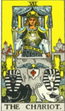 |  | The sun shines in the zenith, and beneath is a great winged figure with arms extended, pouring down influences. In the foreground are two human figures, male and female, unveiled before each other, as if Adam and Eve when they first occupied the paradise of the earthly body. Behind the man is the Tree of Life, bearing twelve fruits, and the Tree of the Knowledge of Good and Evil is behind the woman; the serpent is twining round it. |  | VI  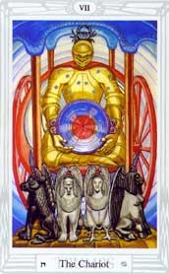 | This card and its twin, XIV, Art, are the most obscure and difficult of the Atu. Each of these symbols is in itself double, so that the meanings form a divergent series, and the integration of the Card can only be regained by repeated marriages, identifications, and some form of Hermaphroditism.  Yet the attribution is the essence of simplicity. Atu VI refers to Gemini, ruled by Mercury. It means The Twins. The Hebrew letter corresponding is Zain, which means a Sword, and the framework of the card is therefore the Arch of Swords, beneath which the Royal Marriage takes place.  The Sword is primarily an engine of division. In the intellectual world-which is the world of the Sword suit-it represents analysis. This card and Atu XIV together compose the comprehensive alchemical maxim: Solve et coagula.

VIII  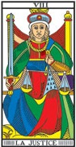 | Balance, attraction and repulsion, life, terror, promise and threat.  Hieroglyph, JUSTICE with sword and balance. | VII  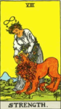 | An erect and princely figure carrying a drawn sword and corresponding, broadly speaking, to the traditional description which I have given in the first part. On the shoulders of the victorious hero are supposed to be the Urim and Thummim. He has led captivity captive; he is conquest on all planes--in the mind, in science, in progress, in certain trials of initiation. He has thus replied to the sphinx, and it is on this account that I have accepted the variation of Éliphas Lévi; two sphinxes thus draw his chariot. | VII  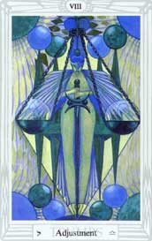 | Atu VII refers to the zodiacal sign of Cancer, the sign into which the Sun moves at the Summer Solstice. [Note that Cheth - Cheth 8-Yod 10-Tau 400-has the value of 418. This is one of the most important of the key numbers of Liber AL. It is the number of the word of the Aeon, ABRAHADABRA, the cypher of the Great Work. (See The Equinox of the Gods, p.138. Also The Temple of Solomon the King.) On this word alone a complete volume could, and should, be written.]

IX  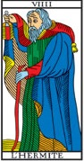 | Good, horror of evil, morality, wisdom.  Hieroglyph, a sage leaning on his staff, holding a lamp in front of him and enveloped completely in his cloak. The inscription is THE HERMIT or CAPUCHIN, on account of the hood of his oriental cloak. His true name, however, is PRUDENCE, and he thus completes the four cardinal virtues which seemed imperfect to Court de Gebelin and Etteilla. | VIII  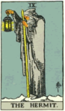 | A woman, over whose head there broods the same symbol of life which we have seen in the card of the Magician, is closing the jaws of a lion. The only point in which this design differs from the conventional presentations is that her beneficent fortitude has already subdued the lion, which is being led by a chain of flowers. For reasons which satisfy myself, this card has been interchanged with that of justice, which is usually numbered eight. | VIII  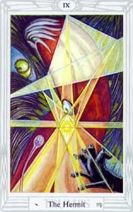 | This card represents the sign of Libra, ruled by Venus; in it Saturn is exalted. The equilibrium of all things is hereby symbolized. It is the final adjustment in the formula of Tetragrammaton, when the daughter, redeemed by her marriage with the Son, is thereby set up on the throne of the mother; thus, finally, she "awakens the Eld of the All-Father."

X  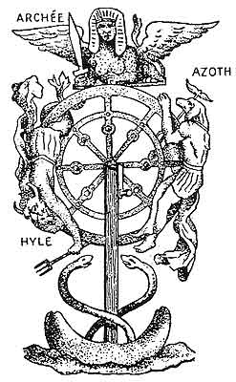  See Note 2  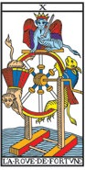 | Principle, manifestation, praise, manly honour, phallus, virile fecundity, paternal sceptre.  Hieroglyph, THE WHEEL OF FORTUNE, that is to say, the cosmogonical wheel of Ezekiel, with a Hermanubis ascending on the right, a Typhon descending on the left and a sphinx in equilibrium above, holding a sword between his lion's claws-an admirable symbol, disfigured by Etteilla, who replaced Typhon by a wolf, Hermanubis by a mouse, and the sphinx by an ape, an allegory characteristic of Etteilia's Kabalah. | IX  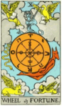 | The variation from the conventional models in this card is only that the lamp is not enveloped partially in the mantle of its bearer, who blends the idea of the Ancient of Days with the Light of the World It is a star which shines in the lantern. | IX  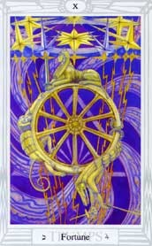 | The letter Yod is the first letter of the name Tetragrammaton, and this symbolizes the Father, who is Wisdom; he is the highest form of Mercury, and the Logos, the Creator of all worlds.  The figure of the Hermit himself recalls the shape of the letter Yod, and the colour of his cloak is the colour of Binah, in whom he gestates. In his hand he holds a Lamp whose centre is the Sun, portrayed in the likeness of the Sigil of the great King of Fire (Yod is the secret Fire).

XI  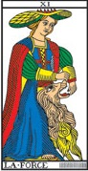 | The hand in the act of grasping and holding.  Hieroglyph, STRENGTH, a woman crowned with the vital closes, quietly and without effort, the jaws of a raging lion. | X  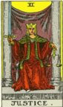 | In this symbol I have again followed the reconstruction of Éliphas Lévi, who has furnished several variants. Typhon is here presented in his serpent form. With the French occultist, and in the design itself, the symbolic picture stands for the perpetual motion of a fluidic universe and for the flux of human life. The Sphinx is the equilibrium therein. | X  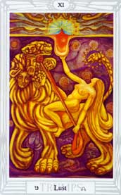 | This Trump was formerly called Strength. But it implies far more than strength in the ordinary sense of the word. Technical analysis shows that the Path corresponding to the card is not the Strength of Geburah, but the influence from Chesed upon Geburah, the Path balanced both vertically and horizontally on the Tree of Life (see diagram). For this reason it has been thought better to change the traditional title. Lust implies not only strength, but the joy of strength exercised. It is vigour, and the rapture of vigour.

XII  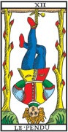 | Example, instruction, public teaching.  Symbol, a man hanging by one foot, with his hands bound behind his back, so that his body makes a triangle, apex downwards, and his legs a cross above the triangle. The gallows is in the form of a Hebrew TAU, and the two uprights are trees, from each of which six branches have been lopped. We have explained already this symbol of sacrifice and the finished work. | XI  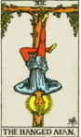 | As this card follows the traditional symbolism and carries above all its obvious meanings. The figure is seated between pillars, like the High Priestess. In its essence, the spiritual justice which is involved belongs to a mysterious order of Providence; the pillars of Justice opening into one world and the pillars of the High Priestess into another. | XI  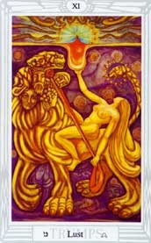  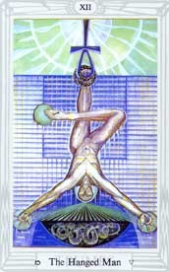 | This Trump was formerly called Strength. But it implies far more than strength in the ordinary sense of the word. Technical analysis shows that the Path corresponding to the card is not the Strength of Geburah, but the influence from Chesed upon Geburah, the Path balanced both vertically and horizontally on the Tree of Life (see diagram). For this reason it has been thought better to change the traditional title. Lust implies not only strength, but the joy of strength exercised. It is vigour, and the rapture of vigour.

XIII  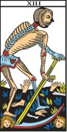 | The heaven of Jupiter and Mars, domination and force, new birth, creation and destruction.  Hieroglyph, DEATH, reaping crowned heads in a meadow where men are growing. |  | XII  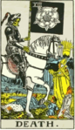 |  | The gallows from which he is suspended forms a Tau cross, while the figure--from the position of the legs--forms a fylfot cross. There is a nimbus about the head of the seeming martyr. It should be noted (1) that the tree of sacrifice is living wood, with leaves thereon; (2) that the face expresses deep entrancement, not suffering; (3) that the figure, as a whole, suggests life in suspension, but life and not death. |  | XII  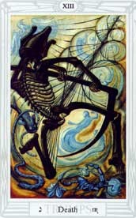 |  | This card, represents the spiritual function of water in the economy of initiation; it is a baptism which is also a death. In the Aeon of Osiris, this card represented the supreme formula of adeptship. The legs are crossed so that the right leg forms a right angle with the left leg, and the arms are stretched out at an angle of 60 degrees; so as to form an equilateral triangle; this gives the symbol of the Triangle surmounted by the Cross, which represents the descent of the light into the darkness in order to redeem it. The whole figure is suspended from the Ankh, another way of figuring the formula of the Rose and Cross, while around the left foot is the Serpent, creator and destroyer, who operates all change.
XIV  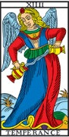 |  | The heaven of the Sun, climates, seasons, motion, changes of life, which is ever new yet ever the same.  Hieroglyph, TEMPERANCE, an angel with the sign of the sun upon her forehead, and on the breast the square and triangle of the septenary, pours from one chalice into another the two essences which compose the Elixir of Life. |  | XIII  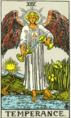 |  | The veil of life is perpetuated in change, transformation and passage from lower to higher, more fitly represented in the rectified Tarot by one of the apocalyptic visions than by the crude notion of the reaping skeleton. Behind it lies the whole world of ascent in the spirit. The mysterious horseman moves slowly, bearing a black banner emblazoned with the Mystic Rose, which signifies life. Between two pillars shines the sun of immortality. The horseman carries no visible weapon, but king and child and maiden fall before him, while a prelate with clasped hands awaits his end. |  | XIII  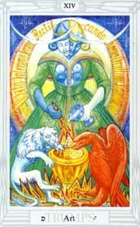 |  | This card is attributed to the letter Nun, which means a fish; the symbol of life beneath the waters; life travelling through the waters. It refers to the Zodiacal sign of Scorpio, which is ruled by Mars, the planet of fiery energy in its lowest form, which is therefore necessary to provide the impulse. In alchemy, this card explains the idea of putrefaction, the technical name given by its adepts to the series of chemical changes which develops the final form of life from the original latent seed in the Orphic egg.

XV  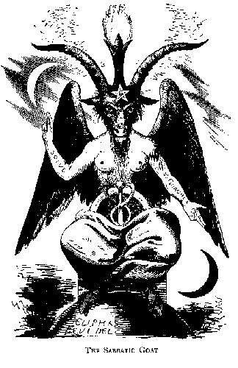  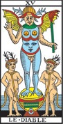 |  | The heaven of Mercury, occult science, Magic, commerce, eloquence, mystery, moral force.  Hieroglyph, THE DEVIL, the Coat of Mendes, or the Baphomet of the Temple, with all his pantheistic attributes. This is the only hieroglyph which was properly understood and interpreted correctly by Etteilla. |  | XIV  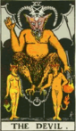 |  | A winged angel, with the sign of the sun upon his forehead and on his breast the square and triangle of the septenary. The figure is neither male nor female. It is held to be pouring the essences of life from chalice to chalice. It has one foot upon the earth and one upon waters, thus illustrating the nature of the essences. |  | XIV  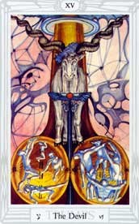 |  | This card is the complement of Atu VI, Gemini. It pertains to Sagittarius, the opposite to Gemini in the Zodiac, and therefore, "after another manner," one with it. Sagittarius means the Archer; and is a picture of Diana the Huntress; one of the lunar goddesses. The occult significance of Sagittarius is the arrow piercing the rainbow; the last three paths of the Tree of Life making the word Qesheth. Sagittarius pierces the rainbow, as it leads from the Moon of Yesod to the Sun of Tiphareth.
XVI  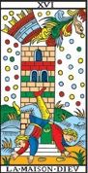 | The heaven of the Moon, alterations, subversions, changes, failings.  Hieroglyph, a TOWER struck by lightning, probably that of Babel. Two persons, doubtless Nimrod and his false prophet or minister, are precipitated from the summit of the ruins. One of the personages in his fall reproduces perfectly the letter Ayin. |  | XV  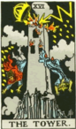 |  | The Horned Goat of Mendes, with wings like those of a bat, is standing on an altar. The right hand is upraised and extended, being the reverse of that benediction which is given by the Hierophant in the fifth card. In the left hand there is a great flaming torch, inverted towards the earth. A reversed pentagram is on the forehead. There is a ring in front of the altar, from which two chains are carried to the necks of two figures, male and female. |  | XV  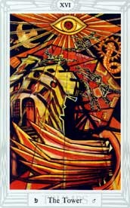 |  | This card is attributed to the letter 'Ayin, which means an Eye, and it refers to Capricornus in the Zodiac. In the Dark Ages of Christianity, it was completely misunderstood. Eliphaz Levi studied it very deeply because of its connection with ceremonial magic, his 4 favourite subject; and he re-drew it, identifying it with Baphomet, the ass-headed idol of the Knights of the Temple. [The Early Christians also were accused of worshipping an Ass, or ass-headed god. See Browning, The Ring and the Book (The Pope).] But at this time archaeological research had not gone very far; the nature of Baphomet was not fully understood. (See Atu 0, above.) At least he succeeded in identifying the goat portrayed upon the card with Pan.

XVII  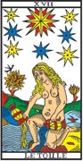 | Heaven of the soul, outpourings of thought, moral influence of idea on form, immortality.  Hieroglyph, the BLAZING STAR and eternal youth. We have described this symbol previously. | XVI  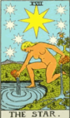 | This card signifies the materialization of the spiritual word; the ruin of the House of We, when evil has prevailed. It is the rending of a House of Doctrine. The reference is to a House of Falsehood. By analogy; one is concerned with the fall into the material and animal state, while the other signifies destruction on the intellectual side. The Tower represents the chastisement of pride and the intellect overwhelmed in the attempt to penetrate the Mystery of God. Of the two persons who are the living sufferers, one is the literal word made void and the other its false interpretation. In yet a deeper sense, it signifies the end of a dispensation. | XVI | This card is attributed to the letter Peh, which means a mouth; it refers to the planet Mars. In its simplest interpretation it refers to the manifestation of cosmic energy in its grossest form. The picture shows the destruction of existing material by fire. It may be taken as the preface to Atu XX, the Last Judgment, i.e., the Coming of a New Aeon. This being so, it seems to indicate the quintessential quality of the Lord of the Aeon.

XVIII  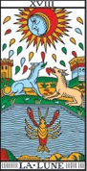 |  |  | The elements, the visible world, reflected light, material forms, symbolism.  Hieroglyph, the MOON, dew, a crab rising in the water towards land, a dog and wolf barking at the moon and chained to the base of two towers, a path lost in the horizon and sprinkled with blood. |  | XVII  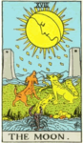 |  |  | A great, radiant star of eight rays, surrounded by seven lesser stars--also of eight rays. The female figure in the foreground is entirely naked. Her left knee is on the land and her right foot upon the water. She pours Water of Life from two great ewers, irrigating sea and land. The figure expresses eternal youth and beauty. The star is l'étoile flamboyante, which appears in Masonic symbolism, but has been confused therein. That which the figure communicates to the living scene is the substance of the heavens and the elements. The mottoes of this card are "Waters of Life freely" and "Gifts of the Spirit." |  |  |  | XVII  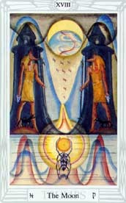 |  |  | This card is attributed to the letter Tzaddi, and it refers to the sign of Aries in the Zodiac. This sign is ruled by Mars, and therein the Sun is exalted. The sign is thus a combination of energy in its most material form with the idea of authority. The sign TZ or TS implies this in the original, onomatopoetic form of language. It is derived from Sanskrit roots meaning Head and Age, and is found to-day in words like Cæsar, Tsar, Sirdar, Senate, Senior, Signor, Sefior, Seigneur.
XIX  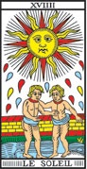 | Composites, the head, apex, prince of heaven.  Hieroglyph, a radiant SUN and two naked children, taking hands in a fortified enclosure. Other Tarots substitute a spinner unwinding destinies, and yet others a naked child mounted on a white horse and displaying a scarlet standard. |  |  | XVIII  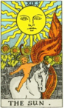 |  |  | The card represents life of the imagination apart from life of the spirit. Beyond the towers is the unknown. The dog and wolf are the fears of the natural mind in the presence of that place, when there is only reflected light to guide it. The intellectual light is a reflection and beyond it is the unknown mystery which it cannot shew forth. It illuminates our animal nature, represented by the dog, the wolf and that which comes up out of the deeps, the nameless and hideous tendency which is lower than the savage beast. It strives to attain manifestation, symbolized by crawling from the abyss of water to the land. |  |  |  | XVIII  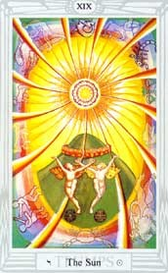 |  |  | The Eighteenth Trump is attributed to the letter Qoph, which represents Pisces in the Zodiac. It is called the Moon.  Pisces is the last of the Signs; it represents the last stage of winter. It might be called the Gateway of Resurrection (the letter Qoph means the back of the head, and is connected with the potencies of the cerebellum). In the system of the old Aeon, the resurrection of the Sun was not only from winter, but from night; and this card represents midnight.
XX  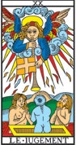 |  | Vegetative principle, generative virtue of the earth, eternal life.  Hieroglyph, THE JUDGEMENT. A genius sounds his trumphet and the dead rise from their tombs. These persons, who are living and were dead, are a man, woman and child -- the triad of human life. |  |  |  | XIX  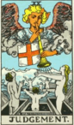 |  |  | This card shows a naked child mounted on a white horse and displaying a red standard. It is the destiny of the Supernatural East and the great and holy light which goes before the endless procession of humanity, coming out from the walled garden of the sensitive life and passing on the journey home. The card signifies the transit from the manifest light of this world, represented by the glorious sun of earth, to the light of the world to come, which goes before aspiration and is typified by the heart of a child. | XIX  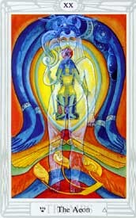 |  |  | This card represents, in heraldic language, "the Sun, charged with a rose, on a mount vert". [Cf. the Coat-of Arms of the family of the Author of this book.]  This is one of the simplest of the cards; it represents Heru-ra-ha, the Lord of the New Aeon, in his manifestation to the race of men as the Sun spiritual, moral, and physical. He is the Lord of Light, Life, Liberty and Love. This Aeon has for its purpose the complete emancipation of the human race.

0  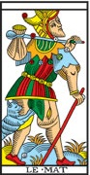 | 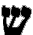 The sensitive principle, the flesh, eternal life.  Hieroglyph, the FOOL. A man in the garb of a fool, wandering without aim, burdened with a wallet, which is doubtless full of his follies and vices; his disordered clothes discover his shame; he is being bitten by a tiger and does not know how to escape or defend himself. | XX | The great angel blows his trumpet, and the dead are rising from their tombs--a woman on the right, a man on the left hand, and between them their child. All the figures are as one in the wonder, adoration and ecstacy expressed by their attitudes. This card registers the accomplishment of the great work of transformation in answer to the summons of the Supernal--which is heard and answered from within. Let the card continue to depict, for those who can see no further, the Last judgment and the resurrection in the natural body; but let those who have inward eyes look and discover that it has been called a card of eternal life, and for this reason it may be compared with Temperance. | XX | The old card was called The Last Judgment. It represented an Angel blowing a trumpet, attached to which was a flag, bearing the symbol of the Aeon of Osiris. Below him, the dead were rising up. The central figure had his hands raised with right angles at the elbows and shoulders, so as to form the letter Shin, which refers to Fire. The card therefore represented the destruction of the world by Fire. This was accomplished in the year of the vulgar era 1904, when the fiery god Horus took the place of the airy god Osiris in the East as Hierophant. The new card is thus, an adaptation of the Stélé of Revealing.

XXI  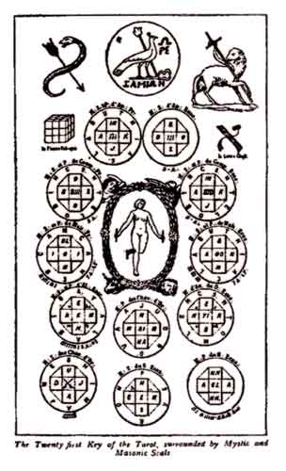  See Note 3  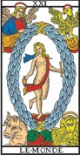 | The microcosm, the sum of all in all.  Hieroglyph, KETHER, or the Kabalistic Crown, between four mysterious animals. In the middle of the Crown is Truth holding a rod in each hand. | XXI  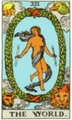 | As this final message of the Major Trumps is unchanged--and indeed unchangeable--in respect of its design, it has been partly described already regarding its deeper sense. It represents also the perfection and end of the Cosmos, the secret which is within it, the rapture of the universe when it understands itself in God. It is further the state of the soul in the consciousness of Divine Vision, reflected from the self-knowing spirit. | XXI  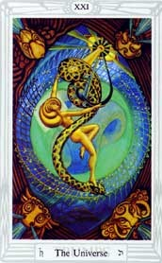 | The first characteristic of this card is that it comes at the end of all, and is therefore the complement of the Fool. It is attributed to the letter Tau. The two cards together accordingly spell the word Ath, which means Essence. All reality is consequently compromised in the series of which these two letters form the beginning and the end. This beginning was Nothing; the end must therefore be also Nothing, but Nothing in its complete expansion, as previously explained.

The images of The Chariot and The Devil/Baphomet are taken from the same book. It is widely believed that they are the two only Tarot images left after Levi. This page shows that there are in fact three more Major Arcana in Levi's published books.
Note 1: The Juggler (Le Bataleur) is taken from a Russian edition of Levi's History of Magic. However the caption attributes this figure to another work of Levi's, Cles Majeures et clavicules de Salomon.
Note 2: "The Tenth Key of Tarot" is taken from the book by Eliphas Levi, La Clef des grands mysteres.
Note 3: "The Twenty first Key of the Tarot surrounded by Mystic and Masonic Seals" is taken from a Russian edition of Levi's History of Magic.

